**WineQuality Prediction**

The below data used for predicting the quality of wine based on the parameters or ingredients portion in it. The prediction model can be made by the machine learning techniques in my future article.

**Content:**

1. Understanding the wine data columns
2. Perform basic data check
3. Perform relation analysis by graphical approach
4. Cleaning the data & checking the relations after cleaning
5. Model Deployment
6. Hyper Parameter Tuning
7. Creating Pipeline

# Understanding the wine data columns

The data-set is related to red and white variants of the Portuguese **“Vinho Verde”** wine

1. **fixed acidity**  
   most acids involved with wine or fixed or non-volatile (do not evaporate readily)
2. **volatile acidity**  
   the amount of acetic acid in wine, which at too high of levels can lead to an unpleasant, vinegar taste
3. **citric acid**  
   found in small quantities, citric acid can add ‘freshness’ and flavour to wines
4. **residual sugar**  
   the amount of sugar remaining after fermentation stops, it’s rare to find wines with less than 1 gram/liter and wines with greater than 45 grams/liter are considered sweet
5. **chlorides** the amount of salt in the wine
6. **free sulfur dioxide**  
   the free form of SO2 exists in equilibrium between molecular SO2 (as a dissolved gas) and bisulfited ion; it prevents microbial growth and the oxidation of wine
7. **total sulfur dioxide**  
   amount of free and bound forms of S02; in low concentrations, SO2 is mostly undetectable in wine, but at free SO2 concentrations over 50 ppm, SO2 becomes evident in the nose and taste of wine
8. **density**  
   the density of water is close to that of water depending on the percent alcohol and sugar con-tent
9. **pH**  
   describes how acidic or basic a wine is on a scale from 0 (very acidic) to 14 (very basic); most wines are between 3–4 on the pH scale
10. **sulphates**  
    a wine additive which can contribute to sulfur dioxide gas (S02) levels, which acts as an antimicrobial and antioxidant
11. **alcohol**  
    the percent alcohol content of the wine
12. **quality**  
    output variable (based on sensory data, score between 0 and 10) that we further transfer like change the quality that in range of 0 to 6 as poor (0) and quality that is or above 7 as good (1).

# ****Perform the basic data check****

**STEP1:** The first thing first, we need to import all the libraries that will support us to do the EDA on our data modelling and Evaluation.

Here, I have imported:

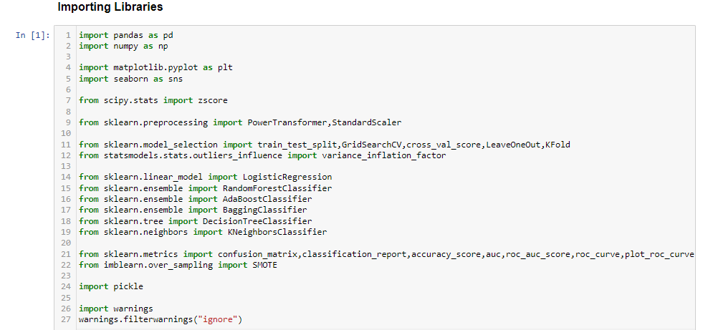

**STEP 2**: Loading the data with python pandas library pd.read_csv.

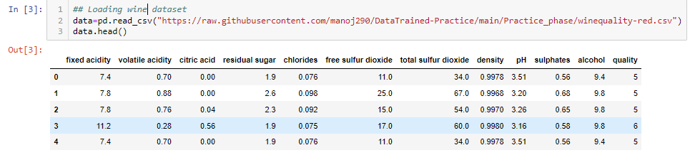

**STEP 3**: Checking Shape of the dataset.

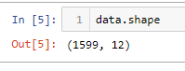

Data has 1599 no. of records and 12 no. of variables.

**STEP 4**: Checking information of the dataset.

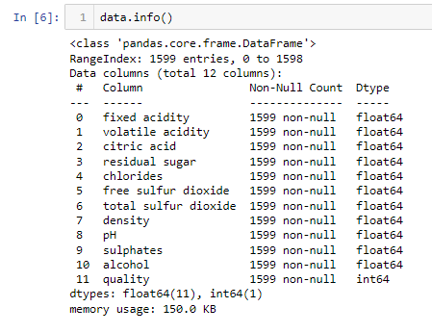

Only Quality columns contains the integer type value that is our label & and all other column are features that are of Decimal type.

**STEP 5**: Checking null values for variables of the dataset.

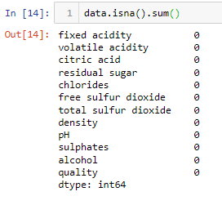

Here we can see that there are no null values in the data.

**STEP 6**: Checking Statistical description for variables of the dataset.

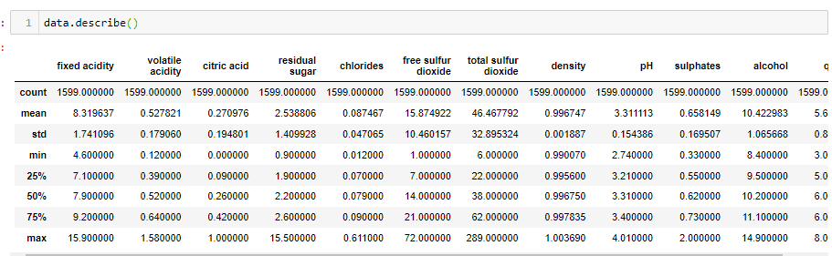

The max Values for variables chlorides, free sulfur dioxide and total sulfur dioxide are seeming to be high enough for wine quality.

Perform relation analysis by graphical approach

**STEP 7**: Doing EDA to know relation of variables with the labels and more to know the dataset.

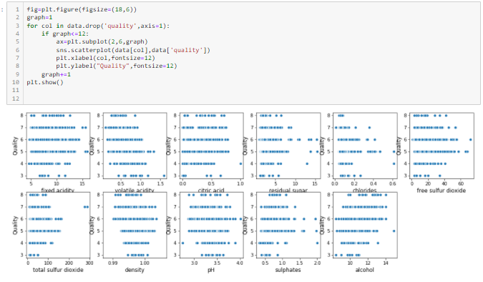

Observations:

* Here we can see that fixed acidity may have some outliers and for range fixed acidity > 14 is continuous data.
* Here we can see that the data is continuous within range 0.2 to 1.1. And, it seem to have some outliers too in it.
* Here we can see that the citric acid column is continuous within range 0.0 to 0.8. And it seems to have some outliers too in it.
* Here we can see that the residual sugar column is continuous within range 2 to 9. And it seems to have some outliers too in it.
* Here we can see that the chlorides column is continuous within range 0.0 to 0.28. And it seems to have some outliers too in it.
* Here we can see that the free SO2 column is continuous within range 0 to 50. And it seems to have some outliers too in it.
* Here we can see that the total SO2 column is continuous within range 0 to 170. And it seems to have some outliers too in it for quality class 1.
* Here we can see that the density column is continuous within range 0.990 to 1.005 for both classes of quality column.
* Here we can see that the pH column is continuous within range 2.8 to 3.8. And it seems to have some outliers too in it.
* Here the data is continuous and have outliers too.
* Here the data is continuous for range 8 to 14.

### **Checking Data Distribution**

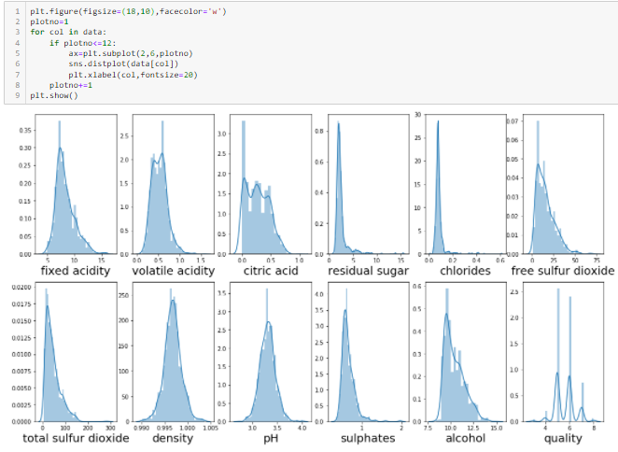

Observations:

Graph1:

In this the 'fixed acidity' column that is continuous is seems to be skewed.

Graph2:

In this the 'volatile acidity' column i.e., continuous column is not normally distributed.

Graph3:

In this the 'citric acid' column it seems to be that data is normally distributed.

Graph4:

In this the 'residual sugar' column the data is highly skewed.

Graph5:

In this the 'chlorides' column the data is highly skewed.

Graph6:

In this column i.e. 'free sulfur dioxide' is not Normally Distributed or skewed.

Graph7:

In this column i.e. 'total sulfur dioxide' is not Normally Distributed or skewed.

Graph8:

In this column i.e. density is normally distributed

Graph9:

In this column i.e. 'pH' is normally distributed

Graph 10:

In this column i.e. 'sulphates' is not normally distributed

Graph 11:

In this column i.e., 'alcohol' is not normally distributed

### **Checking for Outliers**

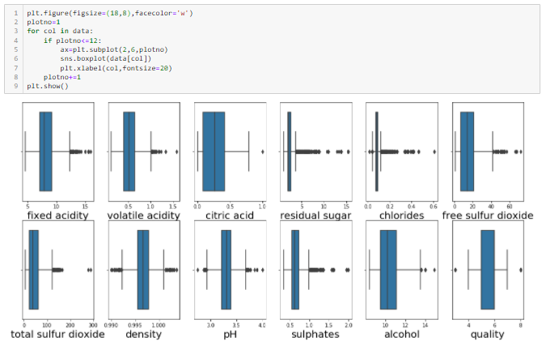

Observations:

##### *Graph1:*

In this the 'fixed acidity' column it seems there are some outliers seems like that are greater than 13.

##### *Graph2:*

In this the 'volatile acidity' column it seems there are some outliers seems like that are greater 1.0.

##### *Graph3:*

In this the 'citric acid' column it seems there are some outliers seems like for value 1.0.

##### *Graph4:*

In this the 'residual sugar' column it seems there are some outliers seems like that are greater 4.

##### *Graph5:*

In this 'chlorides' column it seems there are some outliers seems like that are greater 0.12 & smaller then 0.05.

##### *Graph6:*

In this column i.e., 'free sulfur dioxide' it seems there are some outliers seems like that are greater 42.

##### *Graph7:*

In this column i.e., 'total sulfur dioxide' it seems there are some outliers seems like that are greater 120.

##### *Graph8:*

In this column i.e., density it seems there are some outliers seems like that are greater 1.001 & smaller then 0.992.

##### *Graph9:*

In this column i.e., 'pH' it seems there are some outliers seems like that are greater 3.7 & smaller then 2.9.

##### *Graph 10:*

In this column i.e., 'sulphates' it seems there are some outliers seems like that are greater 1.1.

##### *Graph 11:*

In this column i.e., 'alcohol' it seems there are some outliers seems like that are greater 14.

### **Checking for Multi-Collinearity:**

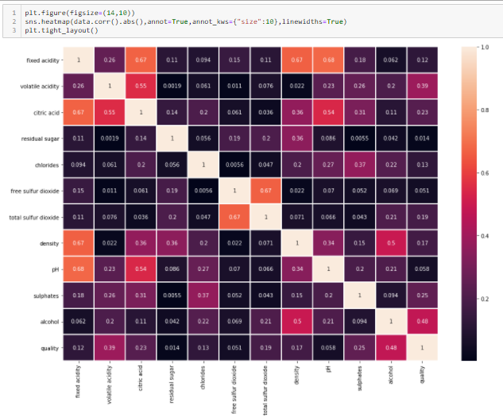

It’s seeming like there is problem existing with multicollinearity.:

1. 'fixed acidity' is 67%,67% & 68% colinear with 'citric acid', 'density' & 'pH'.

2.'free sulfur dioxide' is colinear with 'total sulfur dioxide' i.e., 67%.

**Let’s plot graph for these collinearity:**

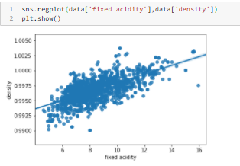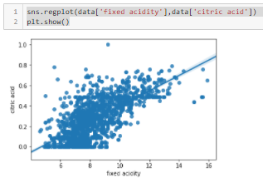

Here we can see the data is deviated and linear dependent too between ‘fixed acidity’ ~ ‘citric acid’. And ‘fixed acidity’ ~ ‘density`.

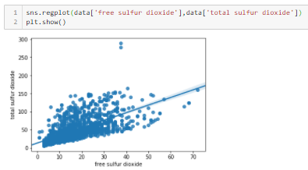

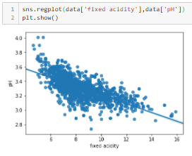

Here we can see there is linear dependent between ‘fixed acidity’ ~ ‘pH’. And ‘total sulfur dioxide’ ~ ‘free sulfur dioxide`.

### **Checking for Relation between features and Label:**

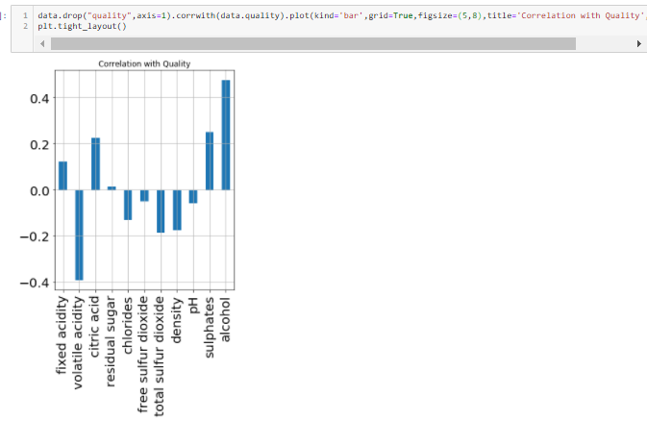

Here we can see the features relations with the target variable. In this graph some features positively corelate with the target variable & some are negatively correlated.

**Transforming Target Variable:**

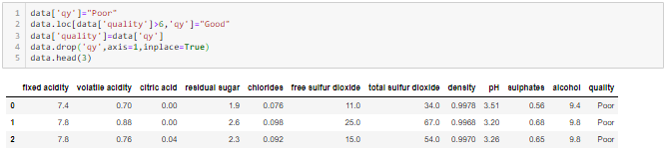

Here we transform quality column in classes poor & good. where poor is the column in which the quality range from 3-6 exists & Good is the quality for 7 & 8.

**Cleaning the data & checking the relations after cleaning**

**STEP 8**: Dropping Duplicates



There were some duplicates values in our data that we dropped.

**STEP 9**: Transforming Column names.

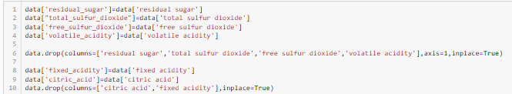

**STEP 10**: Transforming Target.



**STEP 11**: Checking Summary for the data what the pValues for the features.

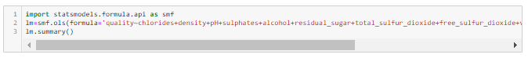

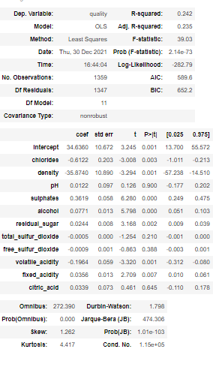

citric_acid,free_sulfur_dioxide,,total_sulfur_dioxide,,pH has pValue greater than 0.05. So, we can remove them.

**STEP 12**: Dropping Columns:



**STEP 12**: Removing Outliers using Z-score technique:

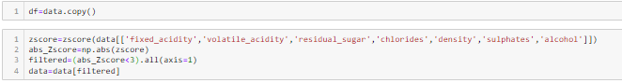

Here we take 3 for removing outliers that means we have taken 99.7% data and lost 0.3% data of each variable that dealt with Z-score and still getting outliers in some columns.

**STEP 13**: Checking for Outliers after using Z-score technique:

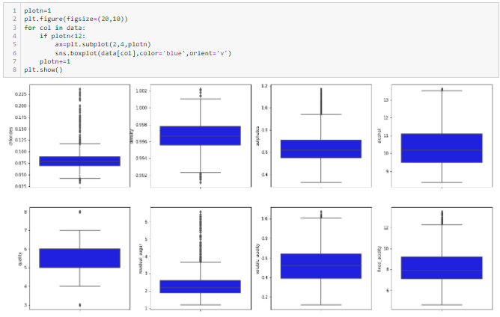

there are still some outliers like in columns 'residual sugar', 'chlorides', 'total sulfur dioxide', 'sulphates' but they are continuous too. Let's see the Statistical description of the data.

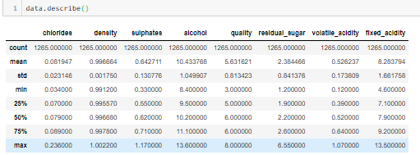

Now data seems to be good as earlier we were concerned about max values now, they also resolved.

**STEP 14**: Data Lost:

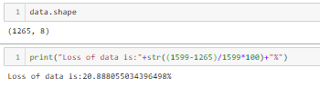

We lost 20.8% data that had duplicates values & outliers in it. That is huge loss and this because there are, 15%+ of data records has duplicates values that we removed.

**STEP 15**: Using Power Transformer technique to distribute the data columns more normally that we analyze in distplot with ‘yeo-johnson’ method because there is negative as well as 0 in the columns:

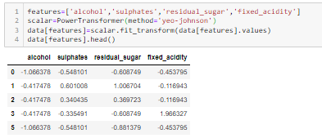

**STEP 16**: Checking distribution of the columns after Power transformer technique:

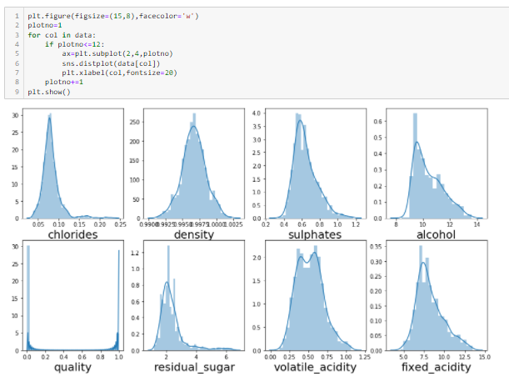

Here we can see all the columns are more normally distributed now.

**STEP 17**: Checking skewness of the columns after Power transformer technique:

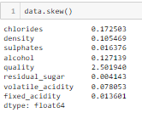

Now data has less skewed values.

**Model Deployment**

**STEP 18**: Splitting data into Features and Labels.



**STEP 19**: Standardized the features.

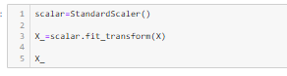

**STEP 20**: Checking Imbalancing of dataset.

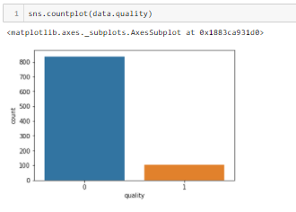

**STEP 21**: Balancing dataset.

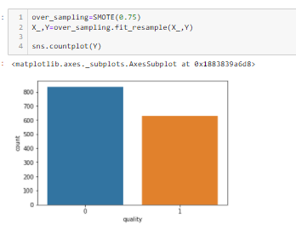

We used over Sampling technique. So, that the either any class that has low no. of count increased. Here we increased 75% of records. Due to which data is balanced now.

**STEP 22**: Increased no. of records.



Now there are 1912 no. of records and 7 standardized features.

**STEP 23**: Code for model’s accuracy and evaluations.

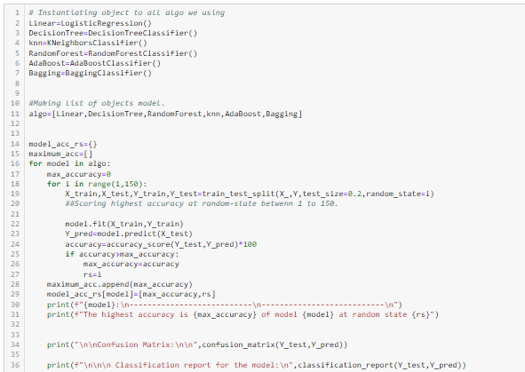

Above code shows the highest **accuracy** for the object that we created for that model that we used are:

* LogisticRegression()
* DecisionTreeClassifier()
* KNeighborsClassifier()
* RandomeForestClassifier()
* AdaBoostClassifier()
* BaggingClassifier()

The highest accuracy for each model we get for Splitting the Training and test features and labels at the **random state** between 1 to 150.

**STEP 23**: The Output of this code shows the highest accuracy, Classification Report and Confusion Matrix.

* **LogisticRegression()**

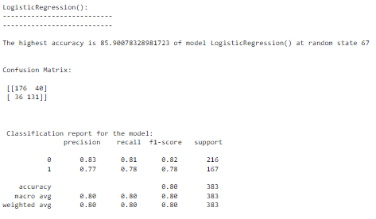

The above code shows that the model has highest accuracy **85.90%** at random state **67**. With **Confusion matrix** and **classification report**.

* **DecisionTreeClassifier()**

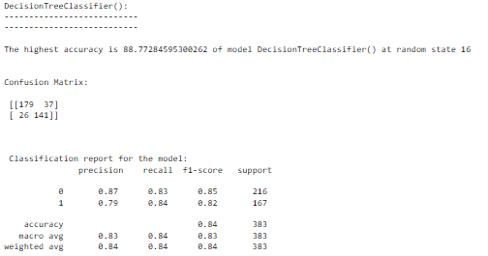

The above code shows that the model has highest accuracy **88.77%** at random state **16**. With **Confusion matrix** and **classification report**.

* **RandomForestClassifier()**

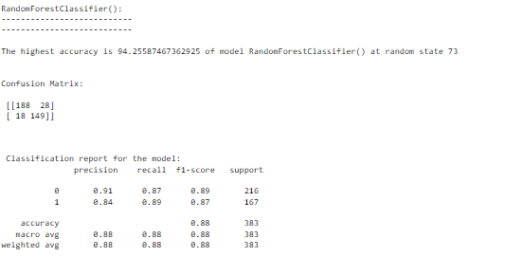

The above code shows that the model has highest accuracy **94.25%** at random state **73**. With **Confusion matrix** and **classification report**.

* **KNeighboursClassifier()**

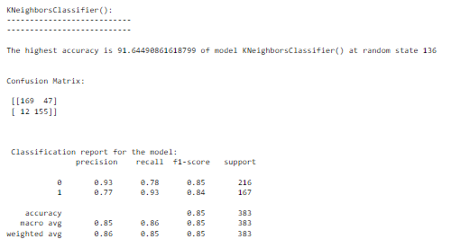

The above code shows that the model has highest accuracy **91.65%** at random state **136**. With **Confusion matrix** and **classification report**.

* **AdaBoostClassifier()**

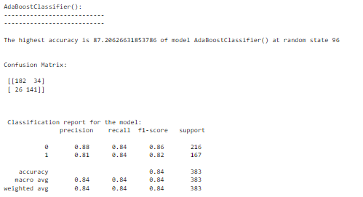

The above code shows that the model has highest accuracy **87.2%** at random state **96**. With **Confusion matrix** and **classification report**.

* **BaggingClassifier()**

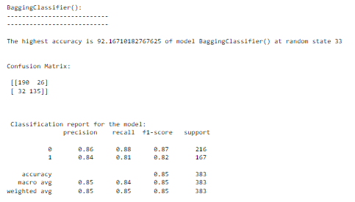

The above code shows that the model has highest accuracy **9.16%** at random state **33**. With **Confusion matrix** and **classification report**.

**STEP 24**: Code for model’s CV score with the best Cross-Validation.

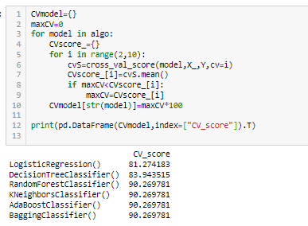

**STEP 25**: Code for least difference between CV Score and accuracy of each Model.

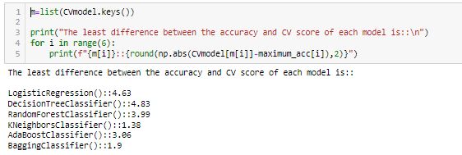

**Model Selection**

Here for model **KNeighborsClassifier** we get the least value i.e., the difference between the accuracy and cv score of this model is **1.38**.

**STEP 26**: Splitting Data into train test dataset.



Splitting Data at random state i.e., best we get accuracy for KneighboursClassifier().

**STEP 27**: Plotting ROC Curve.

Code:

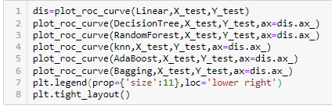

Output:

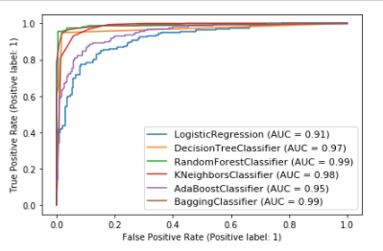

The Output shows the ROC curves are frequently used to **show in a graphical way the connection/trade-off between clinical sensitivity and specificity for every possible cut-off for a test** or a combination of tests.

**Hyper Parameter Tuning**

**STEP 28**: Hyper Tuning the model.

Code:

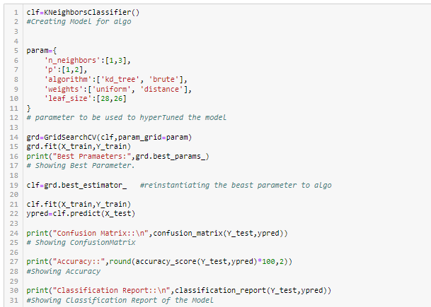

The above code is used to first get the best parameter by Hyper Tuned the model using Grid Search CV technique after the parameter we get from tuning we re-instantiated these parameters to the model after that we get the best accuracy along with that the Confusion Matrix and classification report.

Output:

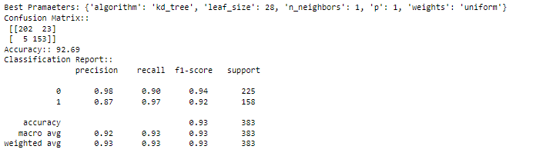

The Output shows the best parameter that we used in model after that we get the best accuracy or increase in the accuracy of the model along with the Confusion Matrix and Classification Report.

# Creating Pipeline:

**STEP 29**: Creating Pipeline for the model.

Code:



Here we created pipeline for the model. Pipeline is **a way to codify and automate the workflow it takes to produce a machine** learning model.

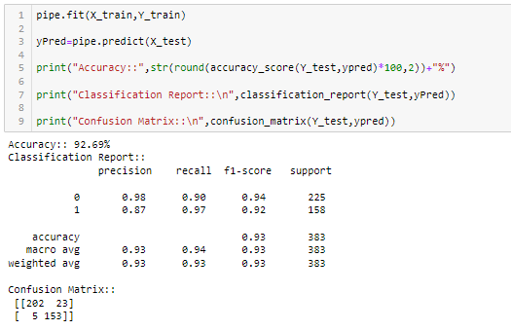

Through pipeline here we predicted the features and showing the accuracy, Confusion Matrix and Classification report.

**STEP 30**: Saving model.



Here we saving the model after creating PipeLine.